**Singleton Design Pattern**

The Singleton design pattern is a creational design pattern that restricts the instantiation of a class to a single object and provides global access to that instance throughout the application. This pattern ensures that only one instance of a class is created and provides a global point of access to it.

**Singleton Object**

Singleton object are the object which are instantiated only once for project (jvm). If we try to get the object then we get same object again and again.

Lazy loading

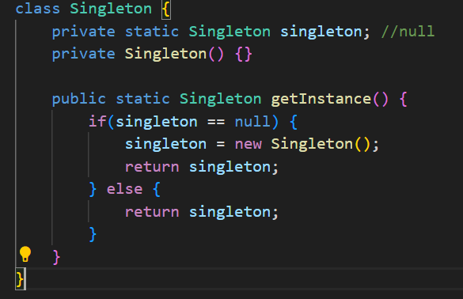

Eager loading



